|  |  |
| --- | --- |
| TANGUB CITY GLOBAL COLLEGE  J. Luna St., Maloro, Tangub City, Misamis Occidental    **INSTITUTE OF COMPUTER STUDIES**  **1st Semester, Academic Year 2024-2025** | |
| Student ID No.: 214527 | Name: Joevie P. Duhaylungsod |
| Schedule: 12:00 – 1:00 (MW) | Date: 19/11/2024 Score: |

**WEBINAR SUMMARY REPORT**

**Webinar 3: 𝗕𝗹𝗼𝗰𝗸 𝗕𝘂𝘇𝘇: 𝗖𝗿𝘆𝗽𝘁𝗼 𝗧𝗮𝘅 𝗖𝗼𝗺𝗽𝗹𝗶𝗮𝗻𝗰𝗲: 𝗪𝗵𝗼 𝗡𝗲𝗲𝗱𝘀 𝘁𝗼 𝗙𝗶𝗹𝗲?**

**Date: September 3, 2024**

**Executive Summary**

The webinar, "𝗕𝗹𝗼𝗰𝗸 𝗕𝘂𝘇𝘇: 𝗖𝗿𝘆𝗽𝘁𝗼 𝗧𝗮𝘅 𝗖𝗼𝗺𝗽𝗹𝗶𝗮𝗻𝗰𝗲: 𝗪𝗵𝗼 𝗡𝗲𝗲𝗱𝘀 𝘁𝗼 𝗙𝗶𝗹𝗲?" led by Penuil Catingub Jr., Chief Finance Officer and Co-Founder at NARA Labs and Crypto Accounting PH, Uncover the complexities of crypto accounting and determine your tax filing obligations. Learn how to accurately track, categorize, and report your cryptocurrency transactions. This session covered a range of understand the specific criteria that qualify you as a tax filer and gain insights into avoiding costly penalties.

**Discussion**

Mr. Penuil Catingub Jr., began by addressing the rise in Cryptocurrency is a financial reality, and so is the need to report it. Penuil Catingub Jr. emphasized the importance of tracking, categorizing, and accurately reporting crypto transactions. Taxable activities include selling, trading, and converting crypto to fiat. Filing correctly helps avoid penalties and ensures compliance. If you’re in crypto, know your obligations stay informed and proactive.

**Concluding Remarks**

The session Crypto is becoming a big part of our financial world, and with that comes the responsibility to handle taxes properly. By keeping track of your transactions and knowing what needs to be reported, you can avoid costly mistakes and stay compliant. It might seem overwhelming, but with the right tools and knowledge, it’s totally manageable.

**CERTIFICATION:**



**REGISTRATION:**

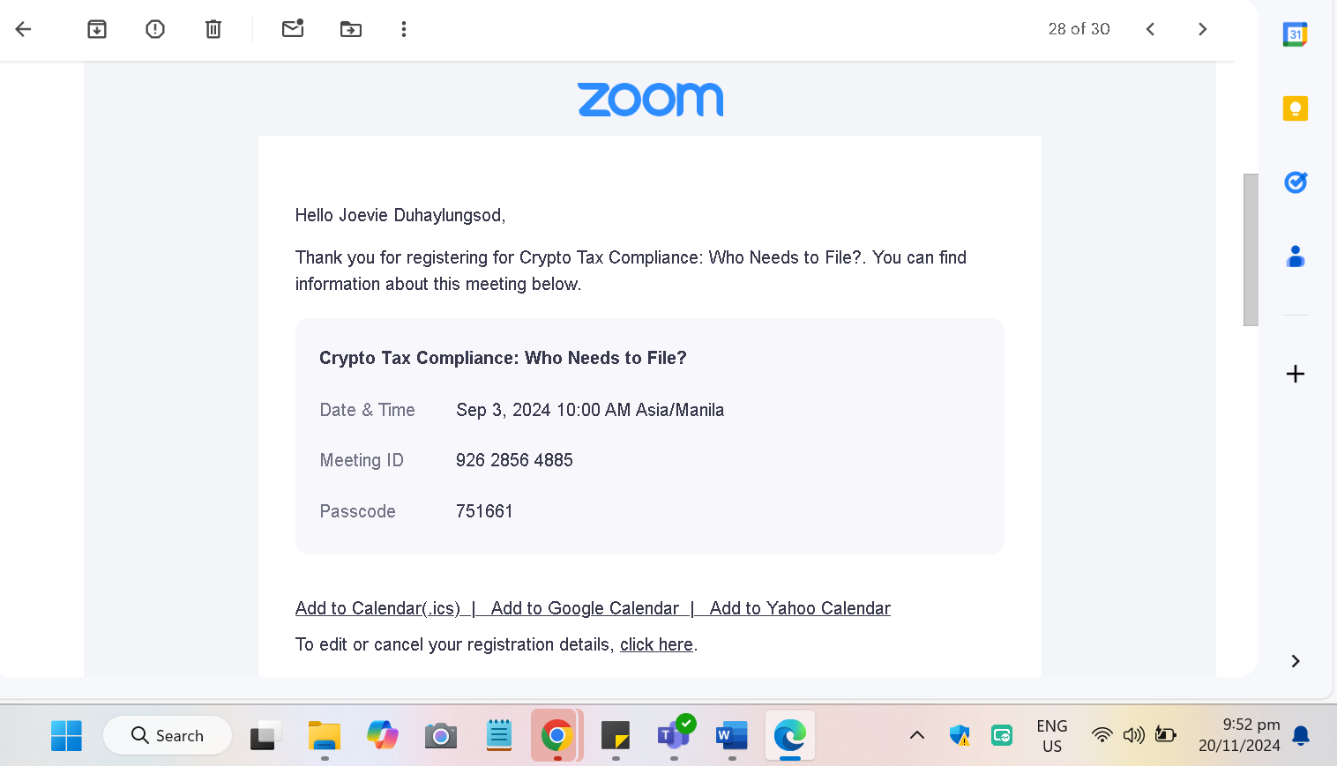

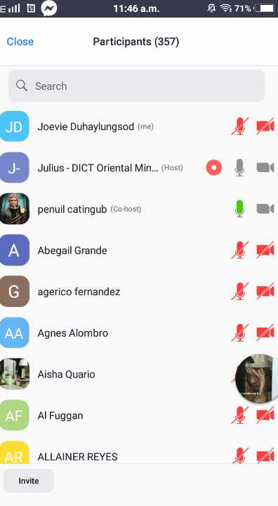**ATTENDANCE AND EVALUATION:**

